Math For the People Review Guide
Project Coordinators: Dr. Mark Branson (mbranson@stevenson.edu) and Dr. Whitney George (wgeorge@uwlax.edu)
Project Homepage
The M4TP Logo CC BY-SA by Mark Branson, based on Carlos88888 / CC BY-SA

Welcome to the guide for Math For the People reviewers. This guide is meant to help you give great, useful feedback on the open textbook we are helping to develop. You are welcome to print this document, make a copy for yourself, or share with others.

Please read through sections below, and use this as a reference as you complete your review. If you have any questions, you can email the project lead.

Before We Begin
As we strive to work openly, all contributions made to this textbook will be licensed under a CC BY-NC-SA 4.0 International License. You will be credited as a reviewer in the published version of the book.

No OER textbook can serve all learners, so it is important to be aware of the context the book is meant to live in. Take a moment to read through the project summary to familiarize yourself with the book’s purpose and audience before beginning your review.

Review Process
Each module will be reviewed by three teams of reviewers - content reviewers, inclusivity reviewers, and accessibility reviewers. While every reviewer should feel free to comment on any changes they think should be made, you will be asked to specifically focus on reviewing content, inclusivity of students from all backgrounds, or accessibility by all students.

All reviewers should create an account at Hypothes.is to use for review. You'll need to submit your Hypothes.is username to the review coordinator when you sign up for review. The review coordinator will add you to the modules that you'll be reviewing so that you can share your review comments with the authors.

This is an open review, so your comments will not be anonymous, and we encourage you to correspond individually with the author(s) about the best way to respond to any review comment. Our intent is to create a supportive community which will produce the best possible text for our students. If you have concerns about the review process, about an author, or about how best to manage a conflict, please reach out to the project coordinators.

About This Book
Math for the People is a new approach to teaching Quantitative Literacy to students outside of traditional STEM fields. By leading with social justice topics, Math for the People seeks to introduce students first to the problems we want to solve, and then introduce the mathematics we can use to understand them.

The text will be structured in stand-alone modules, each related to a single social justice topic. Each module will begin with an overview of the topic, historical context, and a discussion of current questions and concerns related to the topic. This section may include particular case studies related to the topic, articles discussing the topic, and other resources. This section will followed by discussion prompts for faculty to use in helping students explore the issue.

The mathematical content will follow. Each topic will be paired with 2-4 mathematical topics which will help the reader to ask questions and build understanding about the social justice topic being discussed. These mathematical topic sections will be connected directly to the social justice topic. The same mathematical topic may be repeated in multiple places throughout the text (for example, a section on exponential growth may be included in the module on climate change as well as the module on predatory lending – in each section, the topics would be couched in examples related to the social justice topic).

For more information, visit the Project Homepage.

Audience
The textbook is intended for a college freshman level course in quantitative literacy at a two or four-year postsecondary institution. This course would fulfill a terminal mathematics requirement for students whose degree programs do not require any further mathematics. We are not expecting students to have completed any other college-level mathematics, but we do assume a familiarity with traditional topics taught in secondary mathematics education.

Other potential audiences include advanced secondary-level mathematics students and students in humanities or social science courses, where the instructor wishes to infuse more quantitative topics into the course.

Core Components
If there were one single question your review should seek to answer, it should probably be:

“To what extent is the book successful in meeting the needs of its primary market?”
tonybates.ca

When reviewing drafts, also consider:
- Comprehensiveness: The text covers all areas and ideas of the subject appropriately and provides an effective index and/or glossary.
- Content Accuracy: Content is accurate, error-free and unbiased.
- Relevance Longevity: Content is up-to-date, but not in a way that will quickly make the text obsolete within a short period of time. The text is written and/or arranged in such a way that necessary updates will be relatively easy and straightforward to implement.
- Clarity: The text is written in lucid, accessible prose, and provides adequate context for any jargon/technical terminology used.
- Consistency: The text is internally consistent in terms of terminology and framework.
- Organization Structure Flow: The topics in the text are presented in a logical, clear fashion.
- Grammatical Errors: The text contains no grammatical errors.
- Inclusivity: The text is not culturally insensitive or offensive in any way. It should make use of examples that are inclusive of a variety of races, ethnicities, and backgrounds.

This rubric was developed by BCcampus Open Education. This work is licensed under a Creative Commons Attribution 3.0 Unported license.

Project Specific Questions
- Cultural Relevance: The text does not make undue assumptions about student prior knowledge or cultural identity. Consider how different student populations (rural vs. urban, low-income vs. high-income, different racial populations, LGBTQ+ students) would interact with the material and whether any of the material makes assumptions about the reader's background.
- Impartiality: The text deals with sensitive, politically charged topics. All claims should be supported by evidence and unbiased. This is not to say that challenging statements should be avoided - for example, the statement, "the Earth's atmosphere is steadily warming because of greenhouse gas emissions driven by human industry" is an evidence-based statement which some students may find challenging. Rather, we should make sure that the instructors are provided with the resources to defend and explain the claims made in the text.
- Mathematical Relevance: The mathematics taught in each section should be directly relevant to the social justice topic. Examples within the chapter should focus on social justice applications.
- Conceptual Focus: The focus of the text should be on conceptual understanding of quantitative literacy topics, rather than calculation. Seeing calculations is important, but modules are expected to emphasize using technological tools to perform them.
- Structure: All modules have a parallel structure. Here are guidelines for specific issues to look for in each section:
- Objectives: Objectives are appropriate for the level, achievable, and assessable.
- Understanding the Issue: Section covers relevant background for the topic, without introducing significant amounts of mathematics. Background is appropriate for all students and does not make assumptions about background.
- Cui Bono - Who Benefits?: This statement should be evidence-based, and supported by research.
- Big Problem: Big problem is summative of the issue at hand, supported by the previous sections, and of a manageable size for the module.
- Mathematics Topics (2-4): Each mathematics topic uses relevant social-justice examples. Does not use complicated notation, jargon, or formulae. Does not assume sophisticated mathematics knowledge beyond secondary-level mathematics.
- Solving for Change: Focuses on the use of quantitative tools to explore the social justice topic and to create change.
- Reading Questions: These should be strictly conceptual questions, focused on increasing student knowledge about both the social justice and quantitative topics.
- Exercises: These problems can involve calculations, though the focus should be on increasing conceptual understanding and using the quantitative tools to further explore the social justice topic.
- References: The editors will check the reference format.

Accessibility Review
We are asking some of you to specifically review the textbook for accessibility, using the BCcampus Accessibility Checklist. Because many of the accessibility features in the checklist are implemented automatically by PreTeXt, the remaining parts of the checklist are excerpted here.

Organizing content
- Content is organized under headings and subheadings.
Images
- Images that convey information include alternative text (alt text) descriptions of the image’s content or function.
- Graphs, charts, and maps also include contextual or supporting details in the text surrounding the image.
- Images do not rely on color to convey information.
- Images that are purely decorative do not have alt-tag descriptions. (Descriptive text is unnecessary if the image doesn’t convey contextual content information).
Links
- The link is meaningful in context and does not use generic text such as “click here” or “read more.”
- Links do not open in new windows or tabs.
- If a link must open in a new window or tab, a textual reference is included in the link information (e.g., [New Tab]).
Tables
- Tables include row headers (The <row> tag which contains column headers should have <row header="yes">). PreTeXt does not support row headers, so tables should be organized vertically.
- Tables include a caption.
- Tables avoid merged or split cells.
Multimedia
- A transcript is available for each multimedia resource including relevant non-speech content.
  - Transcript includes:
    - speaker’s name
    - all speech content
    - relevant descriptions of speech
    - descriptions of relevant non-speech audio
    - headings and subheadings
- Captions of all speech content and relevant non-speech content are included in the multimedia resource; this includes the audio synchronized with a video presentation.
- Audio descriptions of contextual visuals (e.g., graphs, charts) are included in the multimedia resource.
Formulas
- Formulas have been typed into PreTeXt using LaTeX code (not inserted as images).

Adapted from the Accessibility Toolkit - 2nd Edition by BCcampus, which is licensed under a Creative Commons Attribution 4.0 International License.

Inclusivity Review
We are also asking some of you to review the textbook for inclusivity. We would like Math for the People to be a textbook for all people. These guidelines for inclusivity checking are based on information from the Northwestern University School of Professional Studies guide to inclusive course content.

Gender & Sexual Orientation
- Use gender-neutral (they/them pronouns) or stereotype-rejecting ("she is an engineer", "he is a nurse", etc.) language where appropriate.
- Avoid phrases, examples, and exercises which assume a gender binary ("A class of 20 students consists of 15 men. What percentage of the class are women?"). If working with data which assumes a gender binary, like US Census data, note that this is a problem with the data.
- Avoid "male," "female," and "transgender" used as nouns - these terms are frequently used to support outdated theories about biological sex. These words should only be used as adjectives.
Disability
- Avoid language which reduces a disabled person to their disability ("the blind" instead of "blind people").
- Avoid language which associates a negative connotation to the disability, like "hearing-impaired" or "handicapped."
- There is currently a rich debate among disabled people about the role of "person-first" (people with disabilities) vs. "identity-first" (disabled people) language. Different sub-communities within the disabled community have different preferences. Authors should be consistent in the use of person-first or identity-first language. They should try to use language which is acceptable to the broadest part of the community that they are discussing.
- Avoid colloquialisms and idioms which refer to disability negatively (this equation is really crazy, crippling debt).
Race
- Be specific when talking about issues affecting racial groups. People of color (POC) or Black, Indigenous, and People of Color (BIPOC) can be used where appropriate, but be sure that the issue you are discussing applies to that entire group. For example, a discussion of how "people of color are underrepresented at Ivy League universities" would be inappropriate, since some people of color (Blacks, non-white Hispanics, Native Americans) are underrepresented, while others (Asian Americans) are not.
- Do not use "minorities" as shorthand for racial minorities, or for a specific racial minority.
- Black is always capitalized when referring to Black people.
Culture
- Use examples and exercises which reflect a broad range of cultural experiences.
- Do not assume pre-existing cultural knowledge. A problem which assumes that all students know farmers rotate corn and soybeans to restore soil nutrients would be just as inaccessible to non-rural students as a problem which assumes everyone has seen Citizen Kane.
- Do not assume that anything exists outside of culture. Even "pure mathematics" exists within culture - in how it is taught, how we talk about it, who creates it, and who learns it. Always think about cultural context.

Leaving Feedback
Please leave comments on the web version of the text using Hypothes.is, and/or provide a short memo summarizing your feedback. This memo can be submitted directly to the authorial team for the module you are reviewing. Please also notify the review coordinator when you have finished making your comments in Hypothes.is, if you choose to do so.

How to Use Hypothes.is

In-line Comments
- Open the chapter you are reviewing in your browser.
- Open the Hypothes.is panel by clicking on the left arrow in the sidebar.
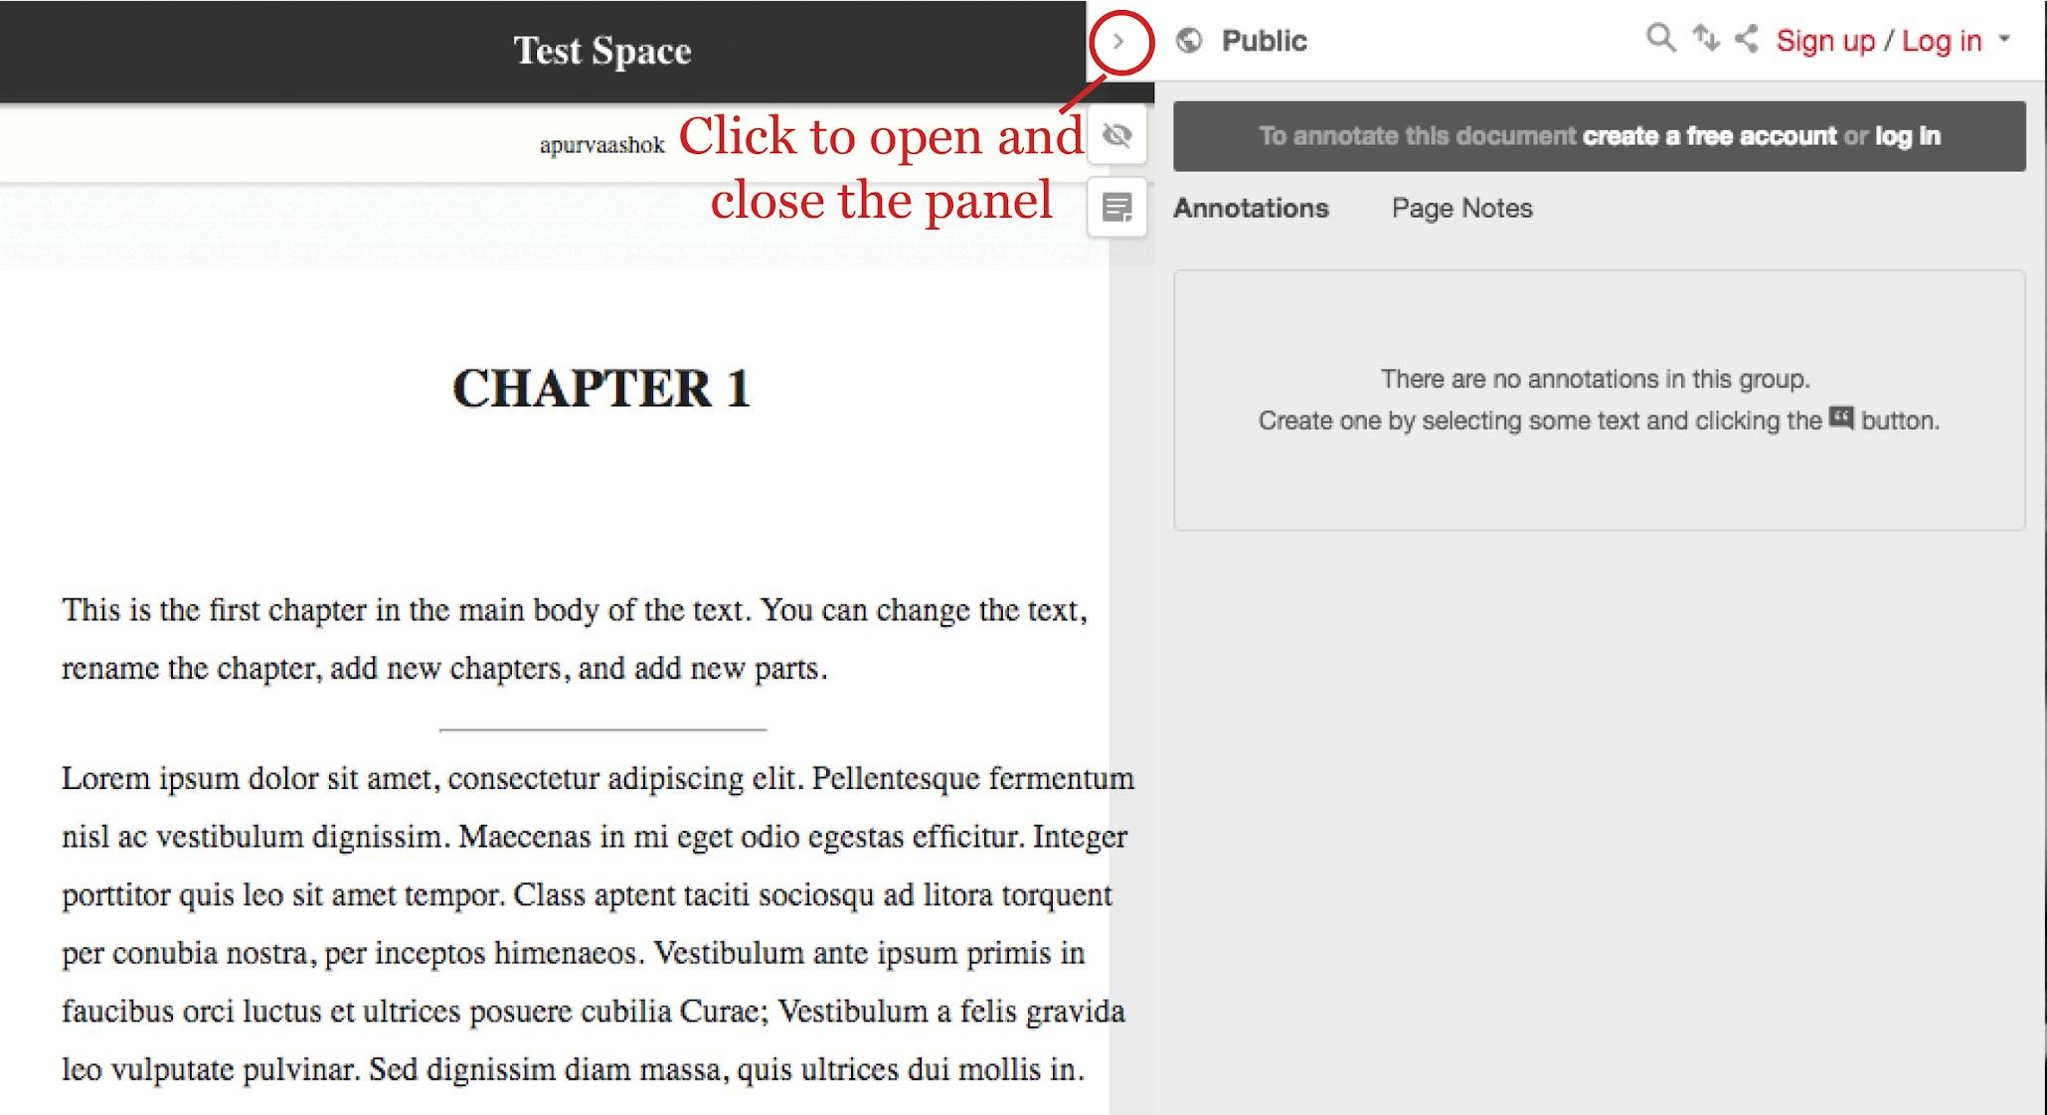
- Log in with your username and password for Hypothes.is.
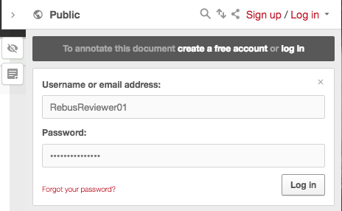
- By default, Hypothes.is annotations are made to the Public group. For the purposes of peer review, a group for each module has been created. To make annotations to this group, click on the dropdown menu next to Public, and select M4TP:<Module Name>. All of your annotations will now be made in this group, and will be viewable only to you, the module authors, and the project coordinators.
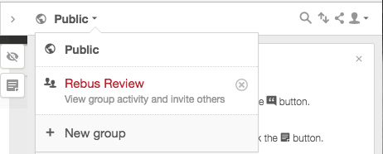
- Select the text you would like to comment on or highlight.
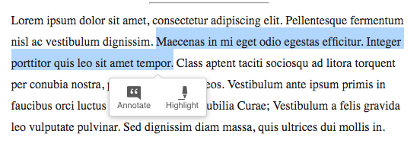
- Click on Annotate to add a comment. You can type in your comment and click on “Post to Rebus Review” to post it in the group.
- You can edit, delete, reply to or share your comment once it has been posted by using the buttons on the bottom-right of the comment box.
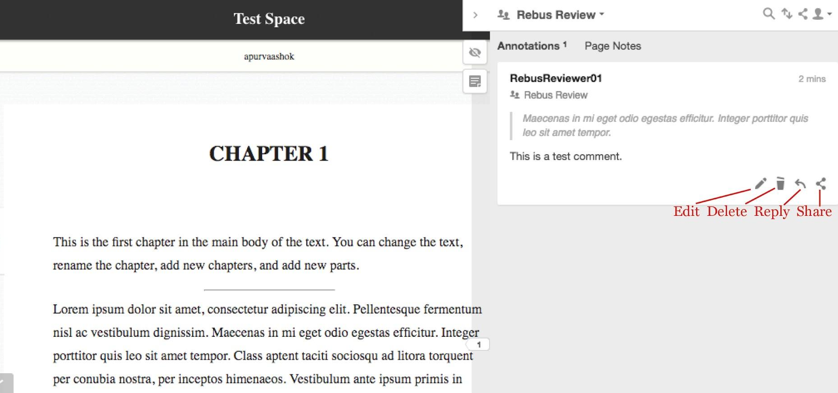

Page Notes
- Log in to Hypothes.is account using your account and password, as described above, and switch to the M4TP:<Module Name> group.
- By default, Hypothes.is is set to display and enter annotations. To enter a longer memo-style note, or view other notes on a particular chapter, click on Page Notes from the top menu.
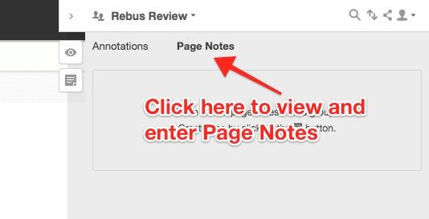
- Click on the page icon to write your own note. You will see a comment box pop-up, where you can type in your lengthier comments.
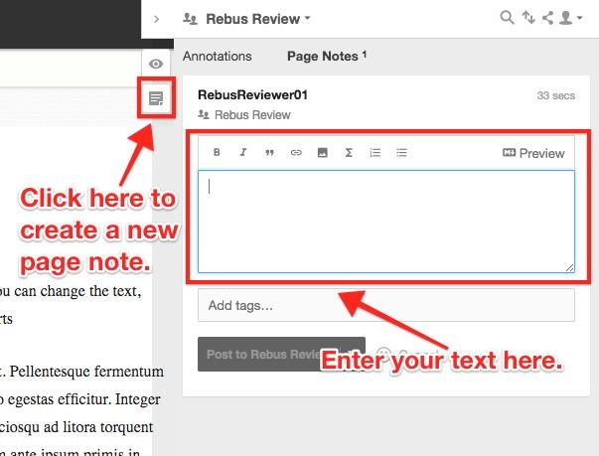
- Once you have finished typing, click on Post to Rebus Review to post your note to the group.
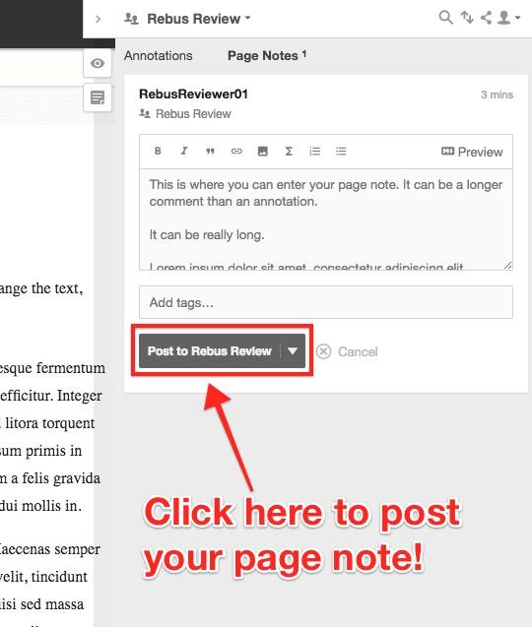
- You can edit, delete, reply to, or share page notes similar to annotations!
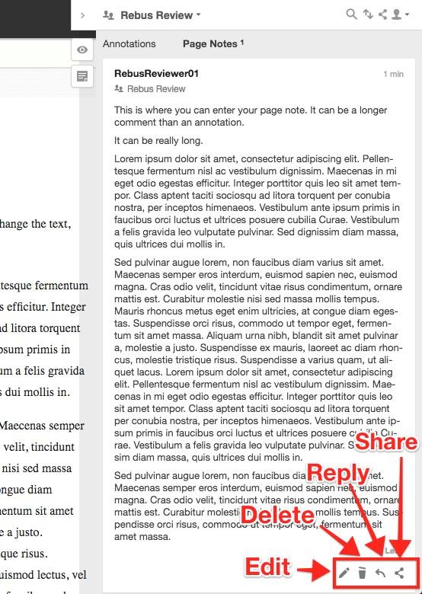

Reviewer Etiquette
When leaving feedback, please be conscious your language and tone and remember that the content you are critiquing is the product of many hours of concerted labor. Keep your criticism constructive, and avoid using derogatory phrases, or making personal remarks about the author. As a courtesy to the author or editor, avoid using abbreviations or short forms of words when providing feedback. Doing so ensures that your feedback remains clear and easy to understand for everyone. Remember too that the review process is open, rather than anonymous. Reviewers who cannot communicate effectively may be removed from the project or moved to another module.

If you run into any issues during this process, please contact the project lead.

Deadline
Because we are using an open review process, we will have a series of deadlines throughout the process.
Date | Review Stage
11/01/21 | Final drafts of modules due.
11/26/21 | Review Assignments made. Review begins. Authors should begin making revisions as they receive comments, and can re-submit new drafts as they are finished.
01/01/21 | Initial Review comments due to Authors.
02/15/22 | Final Reviewed drafts due to the editing team.

Recognition for Reviewers
All reviewers will be recognized in the review statement distributed with the text.

References

- http://llt.msu.edu/guidelines/copyeditingguidelines.pdf
- http://www.unm.edu/~ldbeene/Editing.pdf
- http://www.collegeopentextbooks.org/textbook-listings/how-to-be-a-reviewer
- http://www.tonybates.ca/2015/06/24/guidelines-for-reviewing-an-open-textbook/
- http://open.umn.edu/opentextbooks/ReviewRubric.aspx

This work is licensed under a Creative Commons Attribution Non-commercial Share-Alike 4.0 International License, except where otherwise noted.

This review guide was adapted from the template provided in the The Rebus Guide to Publishing Open Textbooks (So Far) by Apurva Ashok and Zoe Wake Hyde, which was adapted from a similar work created by Billy Meinke-Lau at the University of Hawaii.

